Rate Monotonic Scheduling (RMS)
# Source: AI Source: Provided by: [Data Path: Persons Table -> ID Column: 1, Name_En Column: Motasem Essam] -> From: [ChatGPT] on [1/21/2026]
Rate Monotonic Scheduling (RMS) is one of the most widely used fixed-priority scheduling algorithms in Real-Time Systems (RTS). It is a static scheduling method where task priorities are assigned based on their periodicity.

Definition
# Source: AI Source: Provided by: [Data Path: Persons Table -> ID Column: 1, Name_En Column: Motasem Essam] -> From: [ChatGPT] on [1/21/2026]
RMS is a priority-based scheduling algorithm in which:
- Shorter-period tasks are assigned higher priority.
- Tasks with longer periods have lower priority.
- The schedule is precomputed offline (static).
It is optimal for periodic tasks with fixed execution times in hard real-time systems.

Key Features
# Source: AI Source: Provided by: [Data Path: Persons Table -> ID Column: 1, Name_En Column: Motasem Essam] -> From: [ChatGPT] on [1/21/2026]
- Fixed Priority – Task priorities do not change at runtime.
- Periodic Tasks Only – Designed for tasks that repeat at regular intervals.
- Preemptive – Higher-priority tasks can interrupt lower-priority tasks.
- Predictable – Deadlines can be analyzed in advance for feasibility.

Advantages
# Source: AI Source: Provided by: [Data Path: Persons Table -> ID Column: 1, Name_En Column: Motasem Essam] -> From: [ChatGPT] on [1/21/2026]
- Deterministic: Highly predictable, suitable for hard real-time systems.
- Simple to Implement: Easy to assign priorities based on task periods.
- Optimal for Fixed-Priority Scheduling: Among fixed-priority methods, RMS can schedule the maximum CPU utilization for periodic tasks.

Disadvantages
# Source: AI Source: Provided by: [Data Path: Persons Table -> ID Column: 1, Name_En Column: Motasem Essam] -> From: [ChatGPT] on [1/21/2026]
- Inflexible: Cannot handle aperiodic or sporadic tasks efficiently.
- Priority Inversion Problem: Lower-priority tasks may block higher-priority tasks unless priority inheritance is used.
- Limited CPU Utilization: Maximum guaranteed utilization = n*(2^(1/n) - 1) for n tasks (e.g., ~69% for 2 tasks).

Example
# Source: AI Source: Provided by: [Data Path: Persons Table -> ID Column: 1, Name_En Column: Motasem Essam] -> From: [ChatGPT] on [1/21/2026]
Suppose we have three periodic tasks in an embedded system:
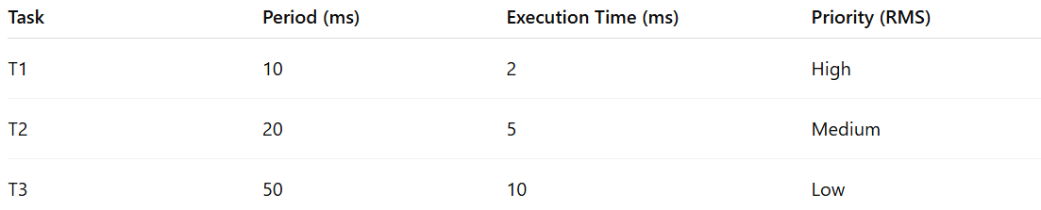
Task | Period (ms) | Execution Time (ms) | Priority (RMS)
T1 | 10 | 2 | High
T2 | 20 | 5 | Medium
T3 | 50 | 10 | Low
- T1 has the shortest period → highest priority
- T2 has medium priority
- T3 has the longest period → lowest priority
The scheduler will preempt lower-priority tasks when T1 or T2 becomes ready, ensuring all tasks meet their deadlines.

Why RMS Matters for Software Engineers
# Source: AI Source: Provided by: [Data Path: Persons Table -> ID Column: 1, Name_En Column: Motasem Essam] -> From: [ChatGPT] on [1/21/2026]
- Foundation for hard real-time embedded systems.
- Helps understand static task prioritization and timing analysis.
- Used in automotive, industrial, and avionics applications where predictability is critical.

